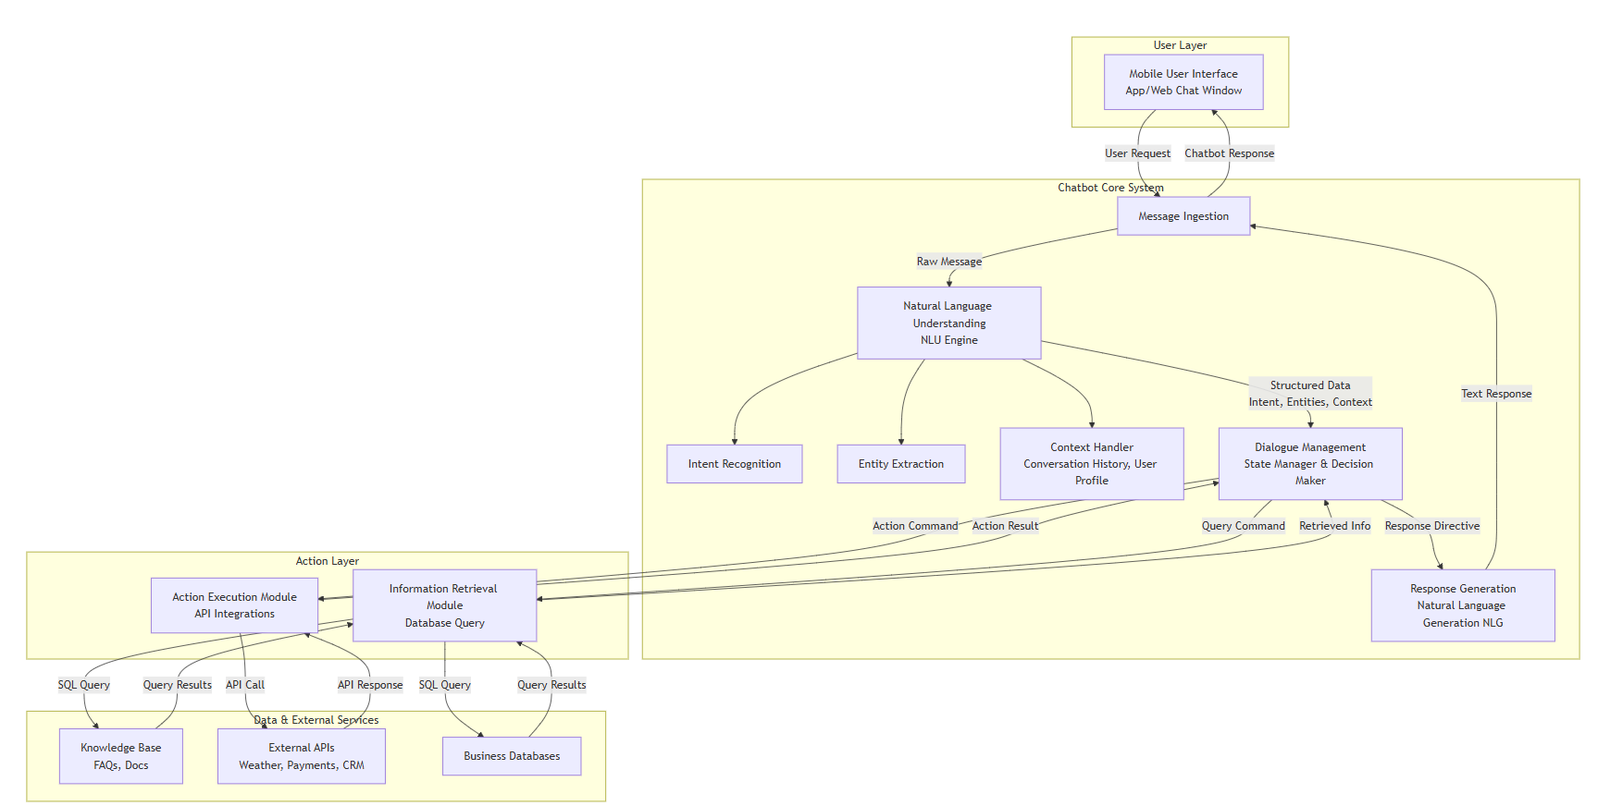

The interpretation of this diagram

1. **User Interface (Mobile user):** This is the app or website the user interacts with. It's the front-end where they type their message and see the chatbot's replies.
2. **User request / Chatbot response:** These are the actual messages passed between the user and the chatbot through the interface.
3. **Language Understanding - User Message Analysis:** This is the core Natural Language Processing (NLP) engine. It takes the user's raw text input and breaks it down to understand:
* **User Intent:** What does the user want to achieve? (e.g., "book a flight," "check weather," "get support").
* **Context Information:** What is the context of the conversation? This includes the conversation history, user's location, time of day, etc., to make the response relevant.
4. **Dialogue Management:** This component decides what to do next based on the understood intent and context. It manages the state and flow of the conversation.
* **Action Execution:** If the user's intent requires performing a task (e.g., "turn on the lights," "add an event to my calendar"), this subsystem triggers that action through an API.
* **Information Retrieval:** If the user asks a question (e.g., "what's your return policy?"), this subsystem queries a database to find the answer.
5. **Data Sources:** The external systems the chatbot connects to for information or actions.
* **Knowledge Base:** The chatbot's internal database or FAQ documents used for information retrieval.
* **Web (URL request):** Represents the ability to call external web services or APIs to fetch live data (e.g., weather API, stock prices, news) or execute actions.
6. **Response Generation:** Once the action is executed or the information is retrieved, this component formulates a natural language response that is sent back to the user through the interface.

**The overall flow is:** User Input -> Understand Meaning -> Decide What to Do -> Retrieve Info/Perform Action -> Generate Reply -> Send Output.

---

### Detailed Architecture Diagram

I have created a more detailed and standardized version of the architecture for you. This diagram expands on the original concepts, adds crucial components (like the NLU engine and APIs), and clarifies the data flow.

```mermaid
flowchart TD
subgraph A [User Layer]
UI[Mobile User Interface<br>App/Web Chat Window]
end

subgraph B [Chatbot Core System]
direction TB
C1[Message Ingestion]
C2[Natural Language Understanding<br>NLU Engine]
C21[Intent Recognition]
C22[Entity Extraction]
C23[Context Handler<br>Conversation History, User Profile]
C3[Dialogue Management<br>State Manager & Decision Maker]
C4[Response Generation<br>Natural Language Generation NLG]

C2 --> C21
C2 --> C22
C2 --> C23
end

subgraph D [Action Layer]
D1[Action Execution Module<br>API Integrations]
D2[Information Retrieval Module<br>Database Query]
end

subgraph E [Data & External Services]
E1[Knowledge Base<br>FAQs, Docs]
E2[External APIs<br>Weather, Payments, CRM]
E3[Business Databases]
end

UI -- User Request --> C1
C1 -- Raw Message --> C2
C2 -- Structured Data<br>Intent, Entities, Context --> C3

C3 -- Query Command --> D2
C3 -- Action Command --> D1

D2 -- SQL Query --> E1
D2 -- SQL Query --> E3
D1 -- API Call --> E2

E1 -- Query Results --> D2
E2 -- API Response --> D1
E3 -- Query Results --> D2

D1 -- Action Result --> C3
D2 -- Retrieved Info --> C3

C3 -- Response Directive --> C4
C4 -- Text Response --> C1
C1 -- Chatbot Response --> UI
```

### Key Improvements and Explanations:

1. **Structured Layers:** The diagram is now organized into clear layers (User, Chatbot System, Action, Data), which is a standard way to represent architecture.
2. **Detailed NLU Engine:** The "Language Understanding" block is broken down into its core sub-tasks:
* **Intent Recognition:** Classifies the user's goal.
* **Entity Extraction:** Identifies key pieces of information (e.g., dates, product names, locations).
* **Context Handler:** Explicitly shows where context (like conversation history and user profile) is managed and used.
3. **Dialogue Management as a State Manager:** This box is now the central decision-making hub. It uses the output from the NLU to choose the correct path: retrieving information or executing an action.
4. **Explicit APIs:** The "Web (URL request)" is now more clearly labeled as **External APIs**, which is what it represents. The "Action Execution" module handles these API calls.
5. **Clear Data Flow:** Arrows now show the exact flow of data:
* How a **query** is sent to a database and **results** are returned.
* How an **API call** is made and a **response** is received.
* How the result of an action or retrieval is sent back to the Dialogue Manager to form a response.
6. **Response Generation (NLG):** This block is highlighted as its own step, where the system decides the best way to phrase the response in natural language before sending it back to the user.

This detailed diagram should give you a much clearer understanding of the components that make up a modern chatbot and how they interact to process a user's request.

